SilverScreen

Use-Case: Generate Recommendations

Version 1.0

Revision History

|  |  |  |  |
| --- | --- | --- | --- |
| **Date** | **Version** | **Description** | **Author** |
| 18.04.2017 | 1.0 | Initial draft | Fabian Blatz |
| 25.04.2017 | 1.1 | Added Function Points | Marcel Borrmann |
|  |  |  |  |
|  |  |  |  |

Table of Contents

1.Use-Case Name 4

1.1Brief Description 4

2.Flow of Events 5

2.1Basic Flow 5

2.2Alternative Flows 5

3.Special Requirements 5

4.Preconditions 5

5.Postconditions 5

6.Extension Points 5

Use-Case Specification:

# Use-Case Name

## Brief Description

The app should generate recommendations for movies based on the movies the user already liked. For that genre and the actors of the liked movies will be taken into consideration at a certain ratio. The Recommendations will be

displayed just as the list of the liked movies in the liked category.

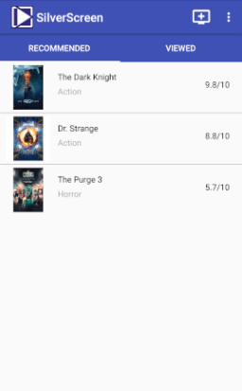**Mockups**:

# Flow of Events

## Basic Flow



## Alternative Flows

#### None

# Special Requirements

The user must have an active Internet connection to connect to our database server and TmDB.

# Preconditions

The user has an activated account and is logged in and also liked some movies. If there a no previous liked movies the recommendation list will contain general popular movies.

# Postconditions

List of fitting recommendations is displayed, movie information is displayed correctly.

# Extension Points

None

# Function Points

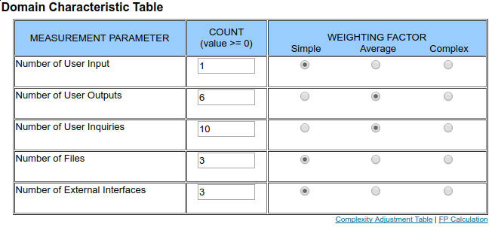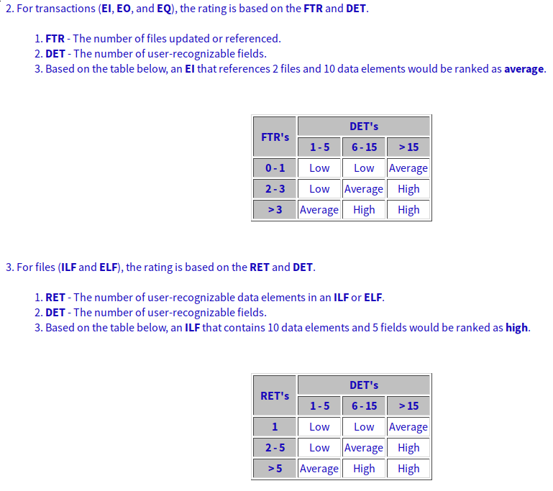RET/DET/FTR: [Her](http://i.imgur.com/vZ1JP73.png)e